Fidgets: My Top 10!
I absolutely love fidgets! Fidgets provide children with tactile and proprioceptive input to better help them focus and attend for structured activities. And, let’s face it - we adults could use a fidget toy every now and then, too! Take, for example, when we’re in a meeting. Often, we can be seen playing with our pen, twiddling our thumbs, etc., just to help us stay alert and pay attention. The average adult, I’ve read, tends to lose focus after fifteen minutes. If this is the case for us, just imagine how tough it must be for our kids – especially when they’re in school, when they’re expected to focus for hours at a time!
I’ve used and recommended lots of fidgets over the years, but these are my top 10 absolute favorites:
10. Chinese Finger Trap: Sure, you or your child may temporarily get your/their finger or thumb stuck in this thing, but it makes for a great fidget!
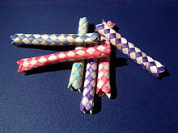
9. Koosh Balls: Love this as a fidget! Provides great tactile input and it feels cool between your fingers, too! Introduced in 1987, whoever would have thought something made out of rubber bands would be such a huge hit?!
8. Sensory Brush: Often used for individuals living with autism, sensory processing disorder and tactile challenges, the sensory brush provides the individual with tactile stimulation and deep pressure. It’s important to first consult with an OT before using this product!
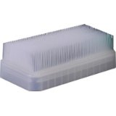
7. Spike Balls: Another great fidget toy that provides kids with tactile input. Classroom Teachers: You might want to show your student how to use/hold it first, otherwise it’ll be bouncing all over the room!
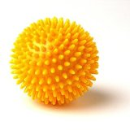
6. Desk Buddy Sensory Bar: Bite it, scratch it, tap it, rub it, the Desk Buddy Sensory Bar is great for kids who are seeking that sensory input at any time during their day!
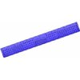
5. Nubby Stretch Ball: Pull it, stretch it, or simply squeeze it, the Nubby Stretch Ball has a super cool feel to it! Just be careful, though! Some have complained that the insides ooze out when it’s stretched too much!
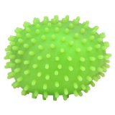
4. Blog Frog: Kids love the Blow Frog! Squeeze it and watch the throat bulge like a real frog! Super cool!
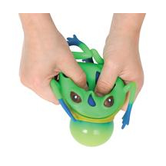
3. Spiky Glove: Terrific for sensory stimulation, the Spiky Glove fits just like a…glove! Kids can’t wait to try it on! Great for tactile input! Kids can also use this during handwriting for increased proprioception!
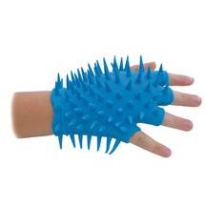
2. IncredibleFoam: Non-toxic, IncredibleFoam’s tiny colorful foam beads provides for a cool tactile experience! I’ve used this with lots of my students in the past and they’ve love it! Kids can manipulate the foam – without making a mess!
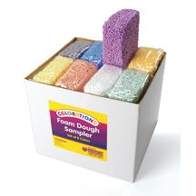
1. Yellow Bendy Man by ToySmith: If you have a child or student with “busy hands,” this just might be the perfect fidget for him! The limbs are long and flexible, allowing your child to create lots of different poses. Turn “busy hands” into “quiet hands” with the Yellow Bendy Man!

