When my Worries get too Big!

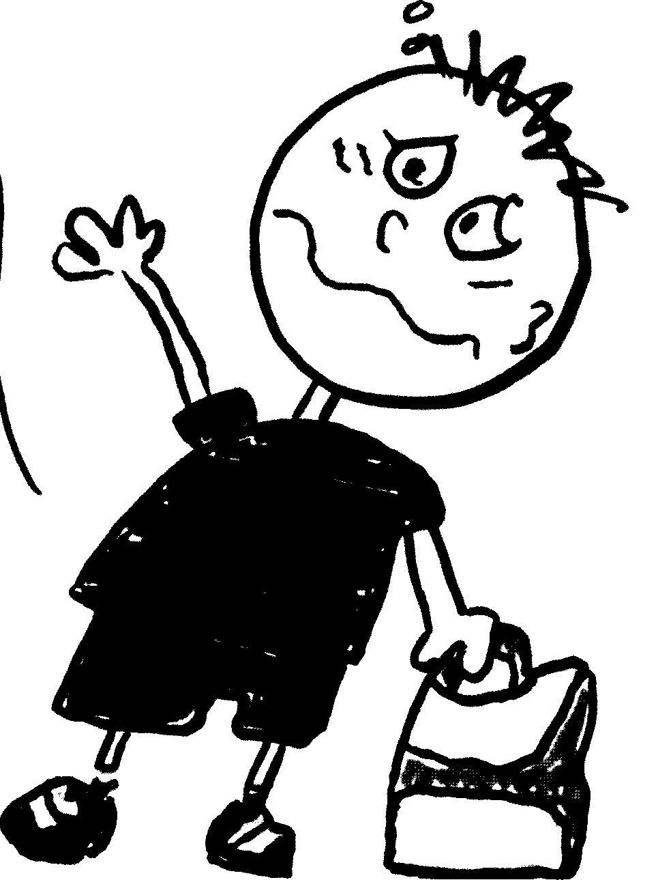

I am a smart boy and that
can be a very good thing.
Some smart kids are really good
at their favorite things.

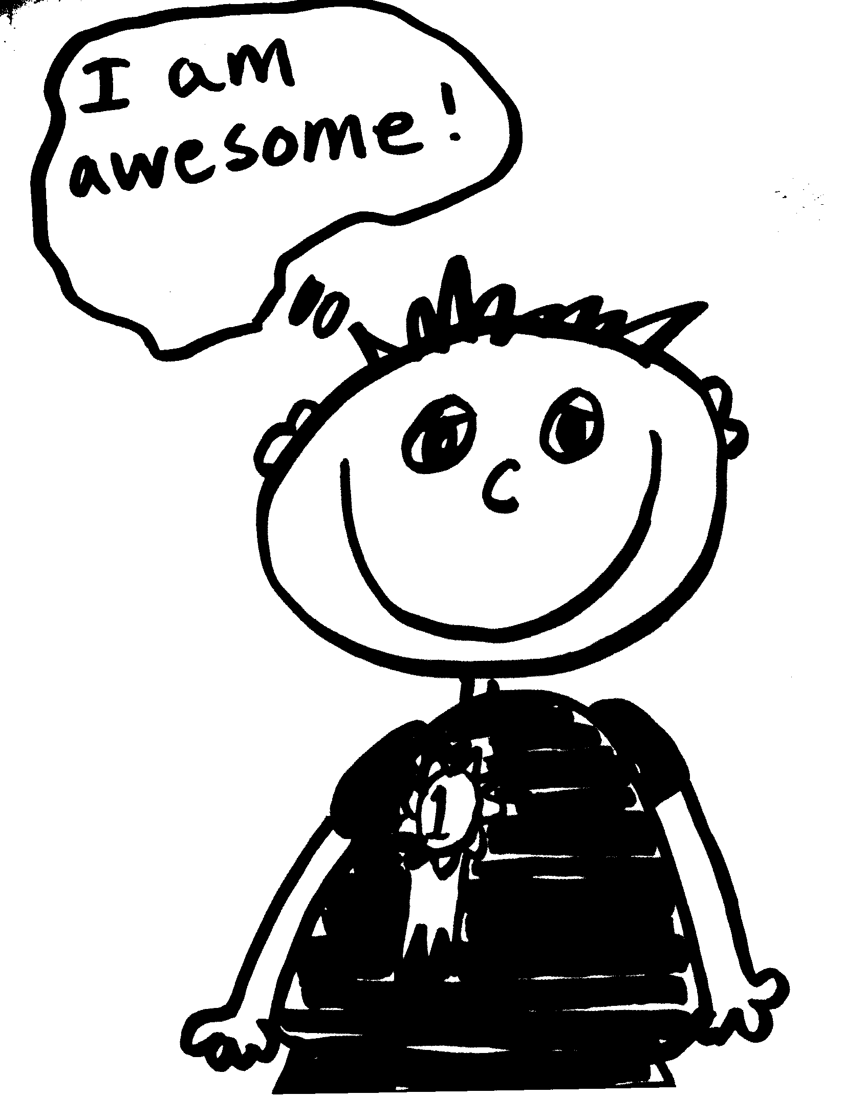

Here I am doing my favorite things.

When I am thinking about my favorite things I am so relaxed. My worries are a 1 or a 2.

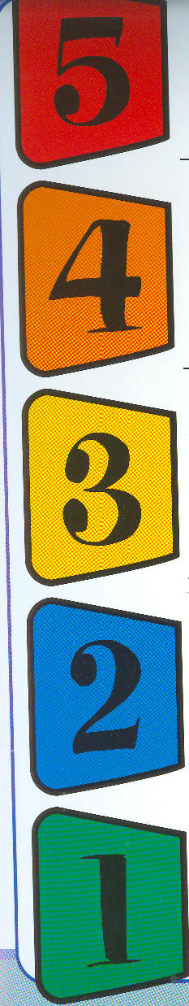

When I know that I can be successful and I really like what I am doing I am also at a 1 or a 2.

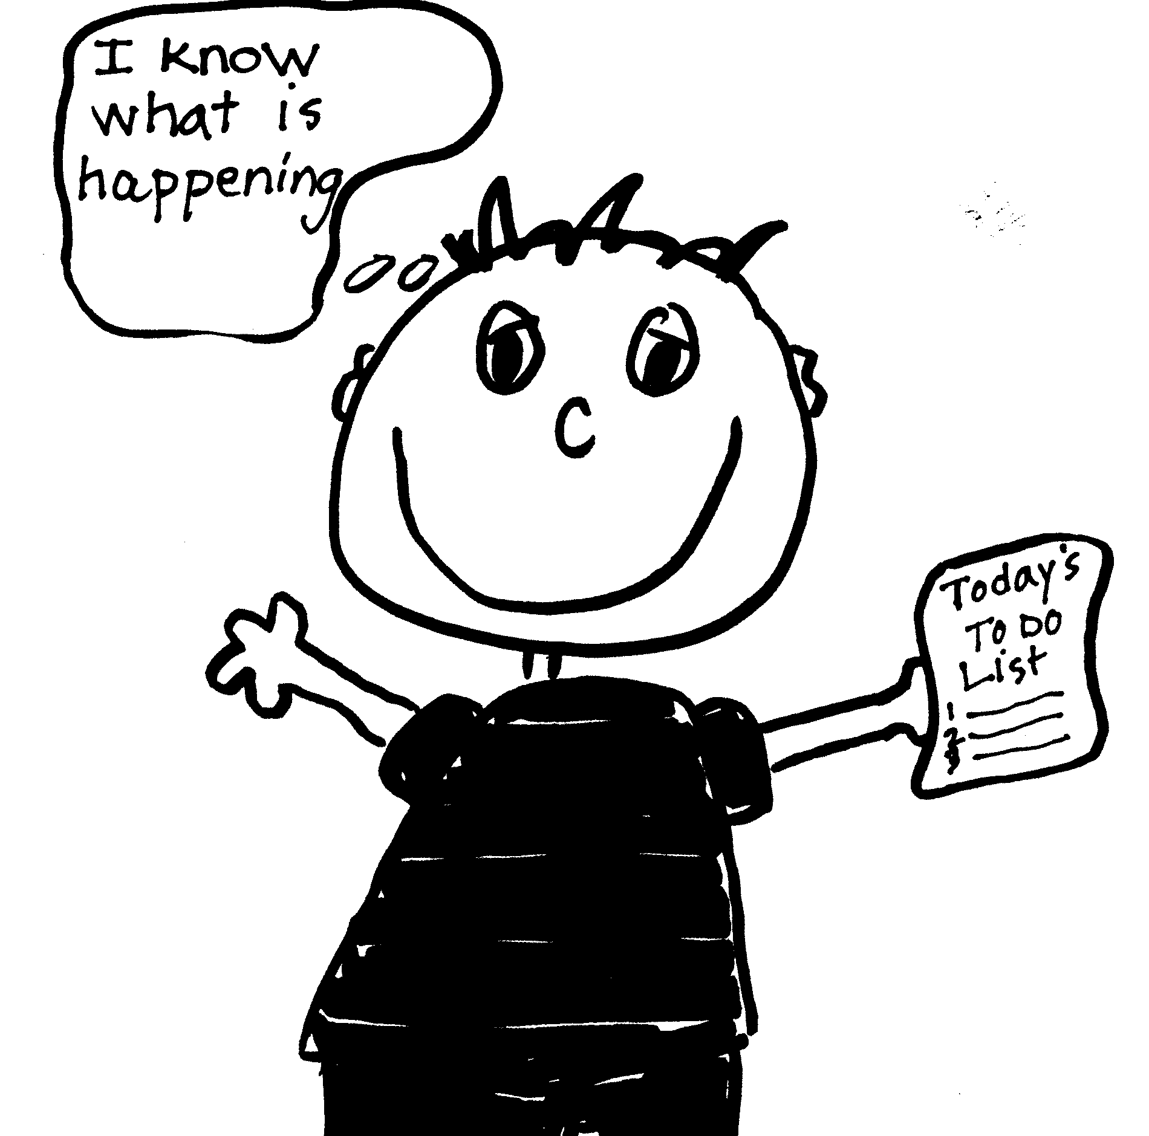

But sometimes I worry too much like when I draw and it isn’t quite perfect. I sometimes worry
about missing mom.

When I worry too much my feelings are at a 4. This makes my body feel bad.
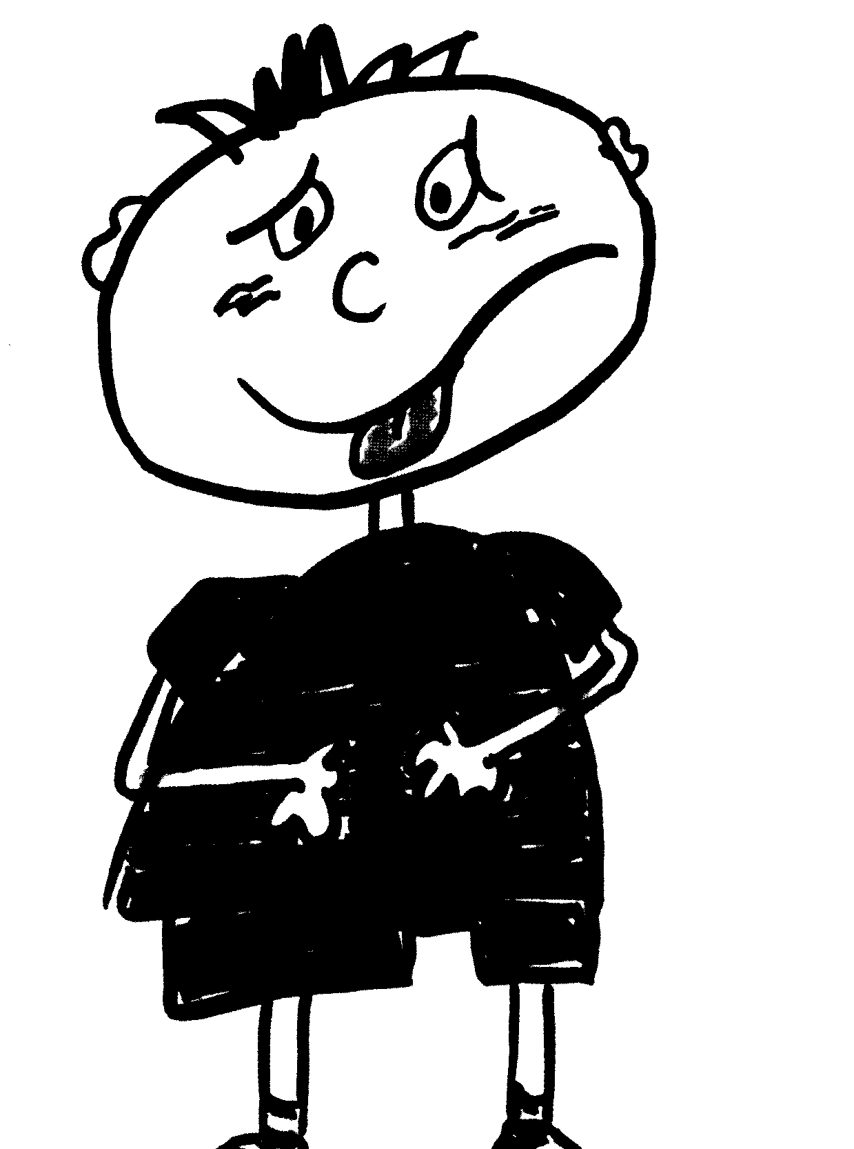

Sometimes I worry way too much, like when I think I might get into trouble for something I did. Or I might worry about my friends. I also worry a lot about seeing the principal.
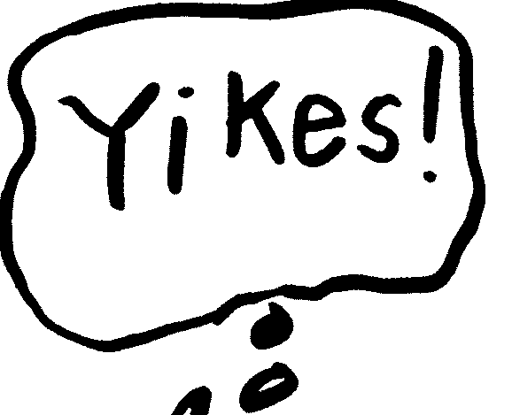


This might make me scream, yell, or cry. I might even tell myself that I am stupid or an idiot.
Now my worries are TOO BIG!
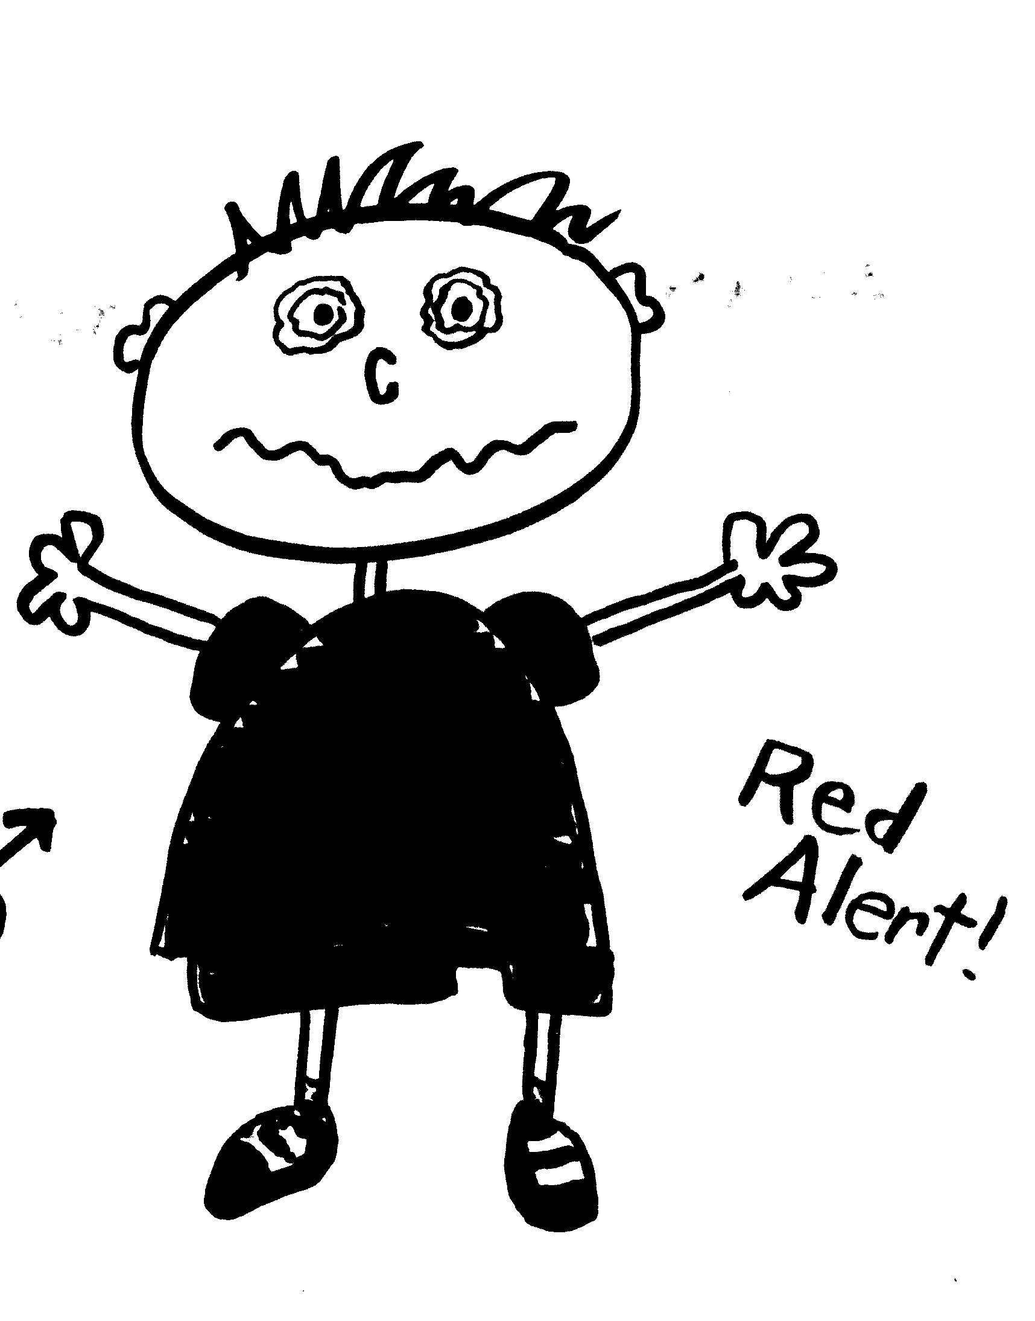
5

One thing that makes my worry too big is… Here is my worry when I am a 5.

This is when I need to scream, yell and
lose control of my body.

First, I can squeeze my hands together.

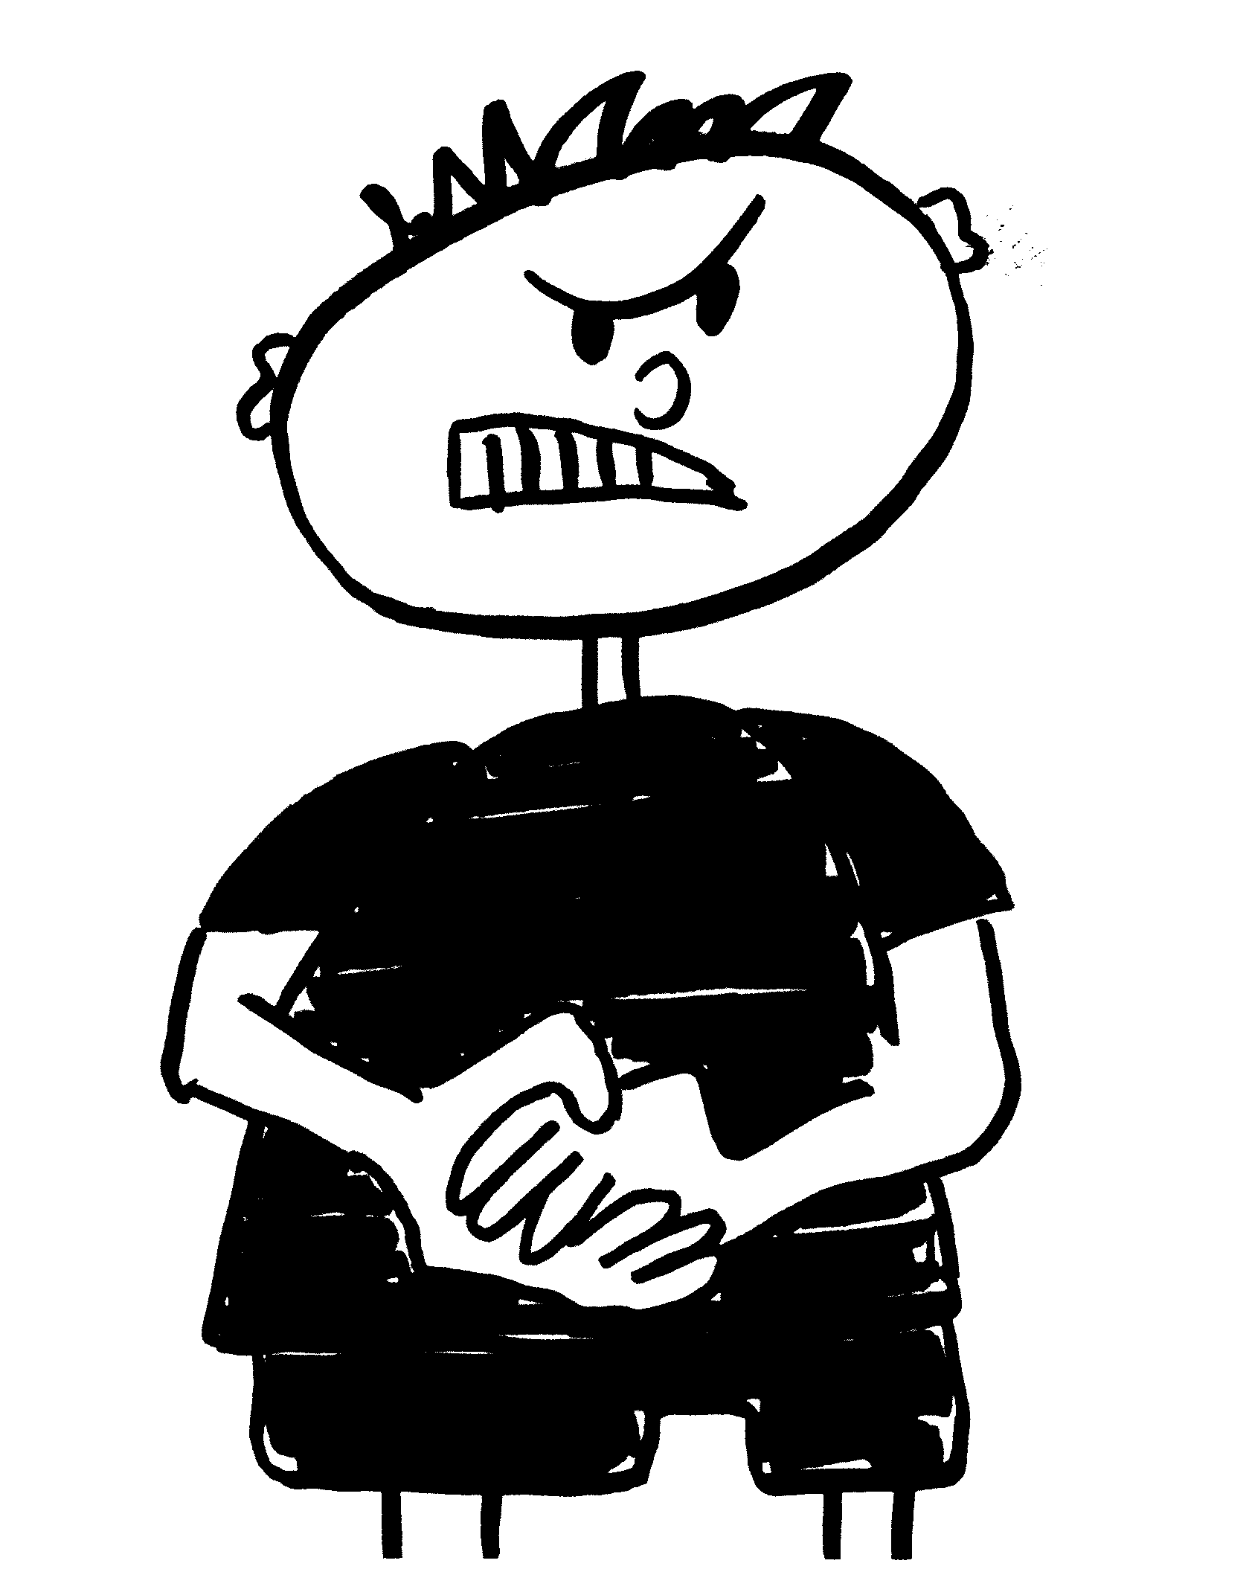

Next, I can take 5 really slow, deep breaths. Slow in-slow out, slow in- slow out, slow in-slow out, slow in-slow out, slow in-slow out.

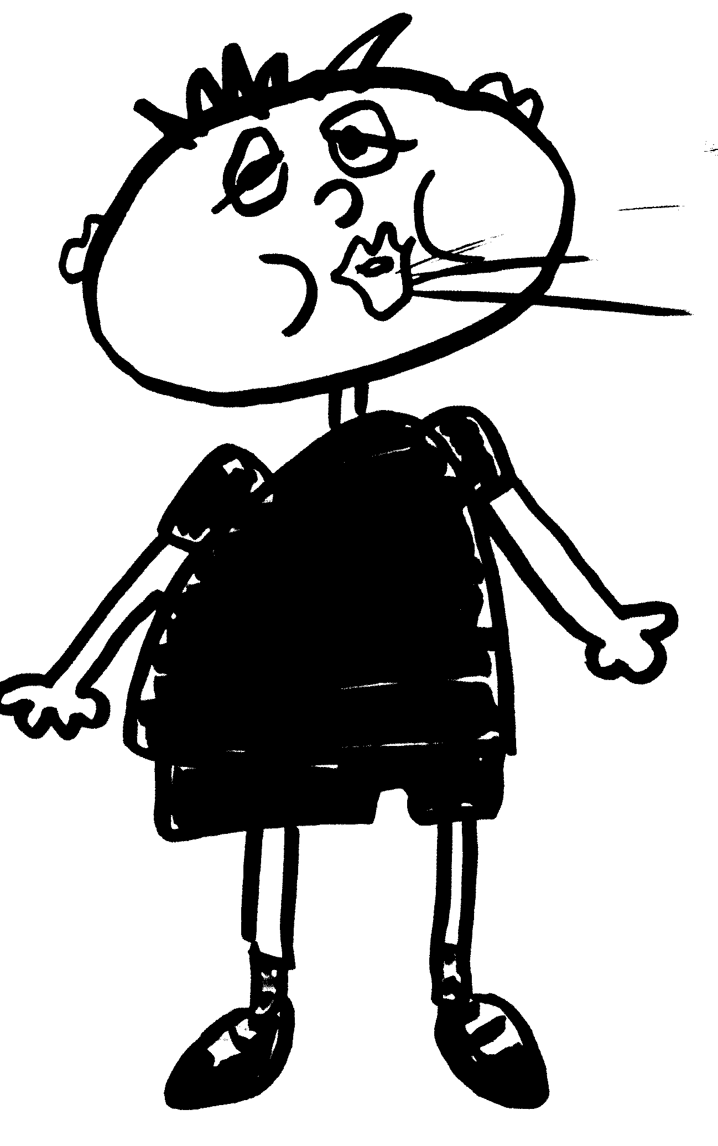

Then I can sit down and close my eyes.
I can even breath a little more.
I feel more like a 3 or a 2.
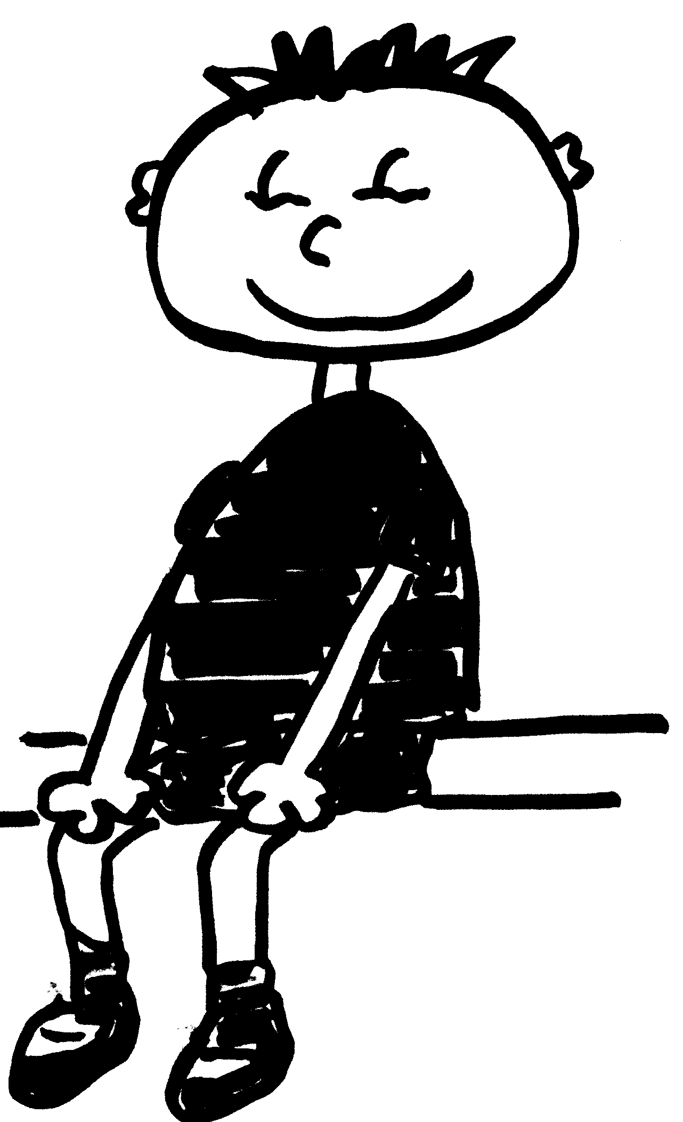

I can think about happy things, like baseball,
Gracie, or going swimming.
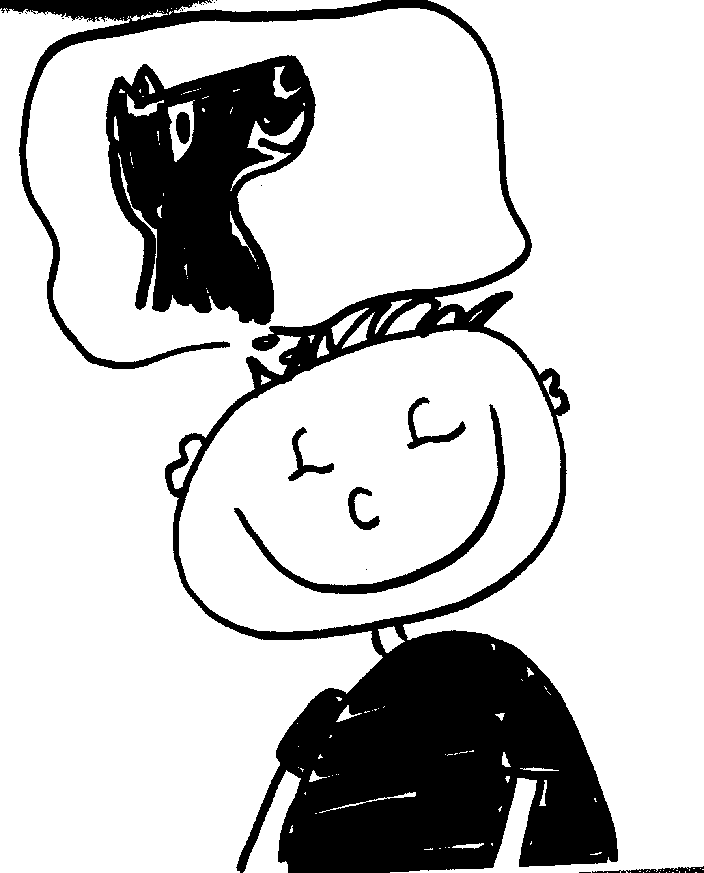

You can do other things to help you relax.
You can go for a walk, go to your bedroom, or go to a safe place at school.

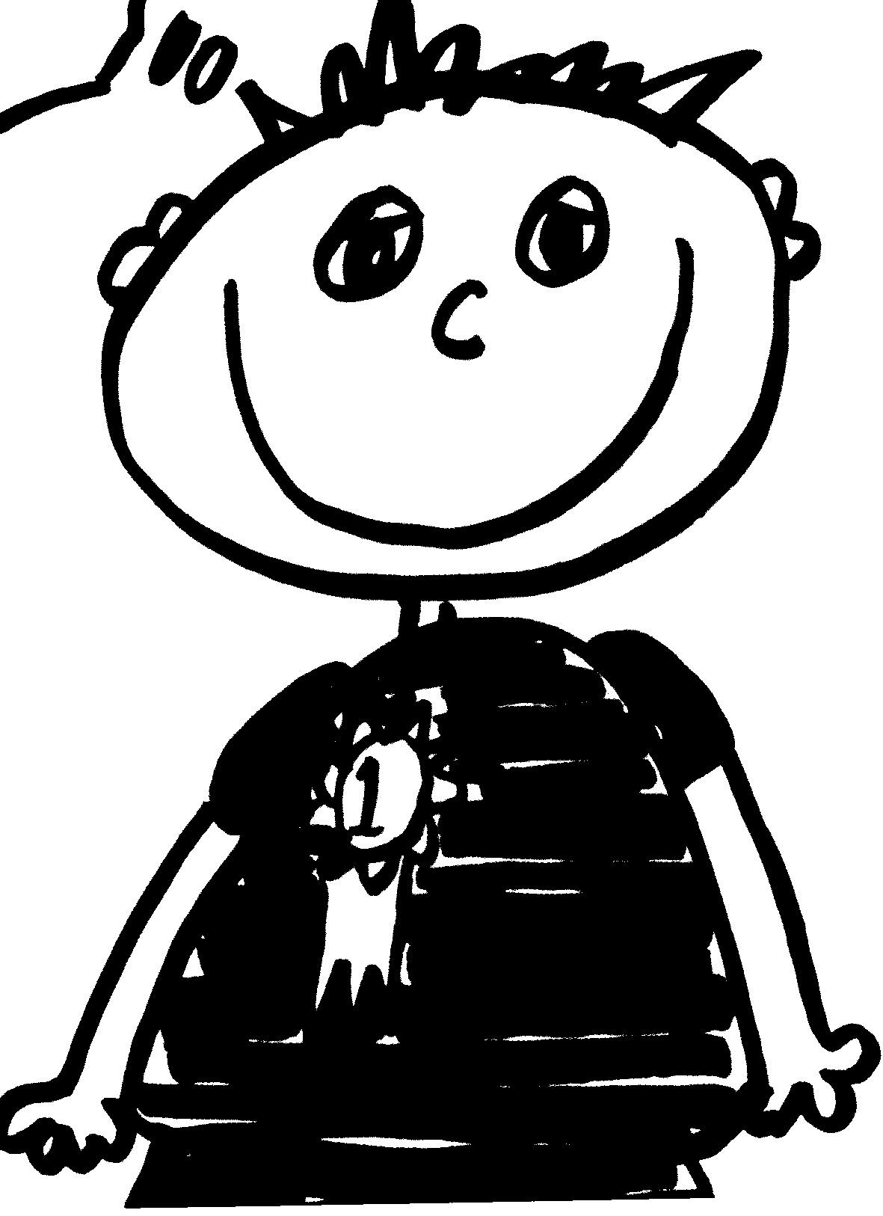

Here I am relaxed and ready to work. I am at a 1, feeling good and feeling proud!


