When My Worries

Get too BIG!

 

** **

Sometimes kids have worries, they

**also have things they are really good at.**

**HH01749_**

**I am really good at video games!**

**When I am thinking about my favorite things,**

**I am so relaxed.**

**HH01749_HH00714_**

**When I don’t have worries I am at a 1.**

****

**But sometimes I worry too much, like when it gets noisy at assemblies. This is a worry like a 2 or 3.**

****

****

**When I worry too much, my worries get bigger. Sometimes bigger worries make my body go crazy! These worries are a 3.**

****

This is like when I have to wear blue jeans or “church shoes.” This is a 3.

“I don’t like the way they feel on my body because they feel too tight.”

BD05128_HH00802_

**This makes me feel squished too tight. Sometimes I complain, I might say “Can I wear something else?”**

**Sometimes my worries get my very upset. I feel like I might want to hit someone or yell but I don’t. Things at school that make me feel this way are…When others tell me “be quiet!” but they aren’t quiet themselves. When others tell me I am breaking a rule but they are breaking rules too but they might not get caught. Sometimes people touch me or bump into me and this gets me really upset.**

****

**This is a 4**

**When my worries are HUGE, I run away from other people and hide. I try to ignore other people but it is hard. I might sometimes hit or scratch others. These worries are a 5! I might clench my fists or kick a wall.**

****

****

# When my Worries are WAY TOO

**BIG I can:**

* **Listen to my teacher or adult 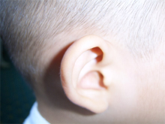**
* **Take a cool down in my special place **
* **Take very slow deep breaths **
* **Hide under a pillow  get deep pressure**
* **Get hard candy to suck on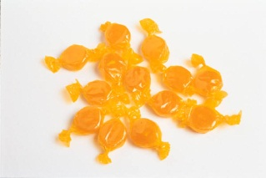**
* **I can think about my happy things like swimming and video games  **

## Here I am relaxed and ready to work

**I am feeling really good and proud.**

**I am ready to make good choices at school or at home.**

****

**I am awesome!**

**Please let me tell you about my worries!**

**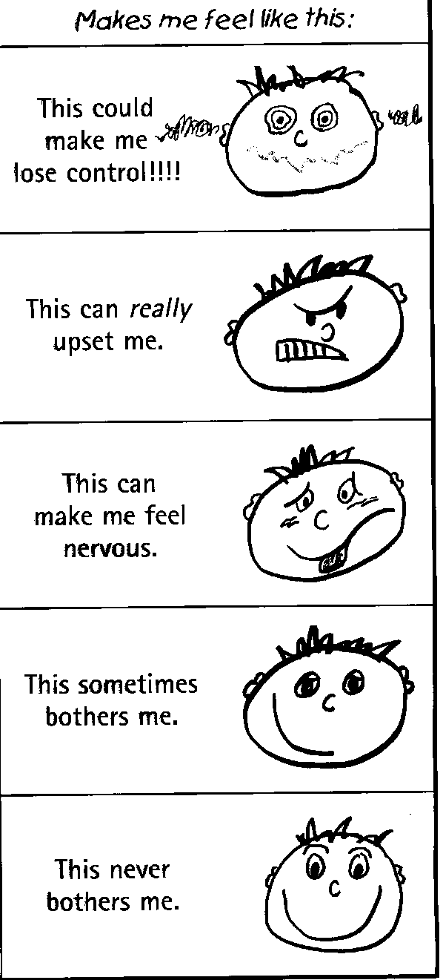**

ACTIVITY/RULES/SENSORY

5

3

2

1

4